

ER Model

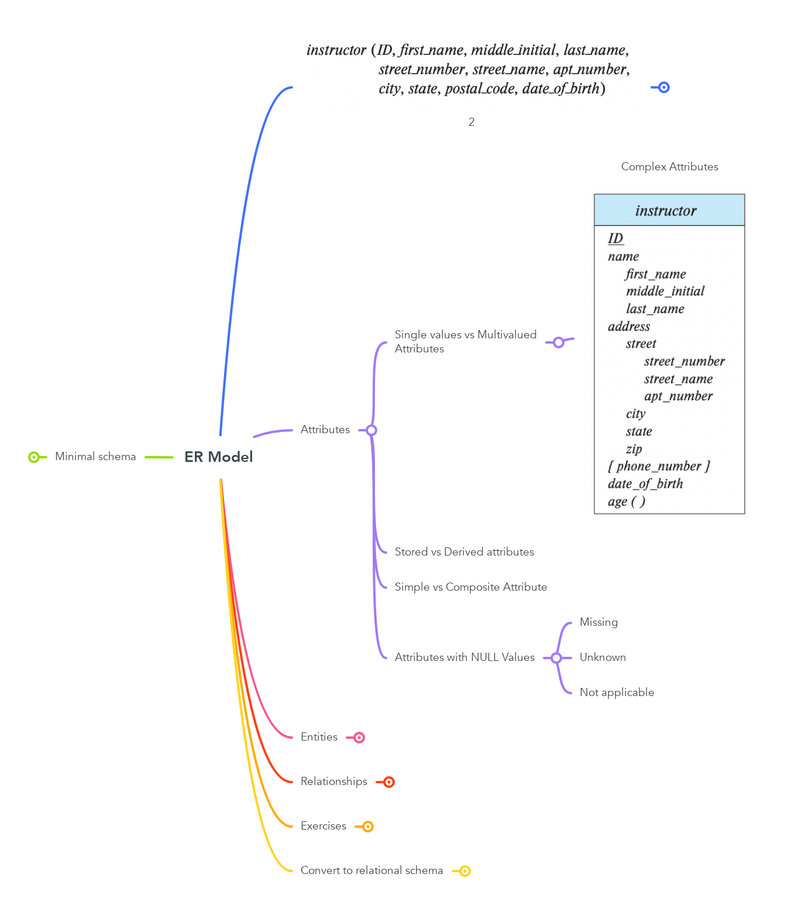

Contents

# Attributes

## Single values vs Multivalued Attributes

### Complex Attributes

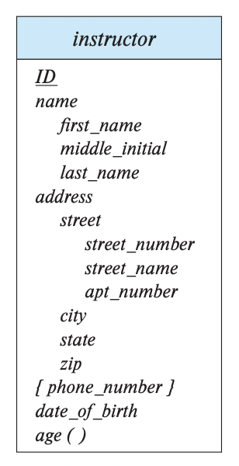

## Stored vs Derived attributes

## Simple vs Composite Attribute

## Attributes with NULL Values

### Missing

### Unknown

### Not applicable

# Entities

## Types

### Strong

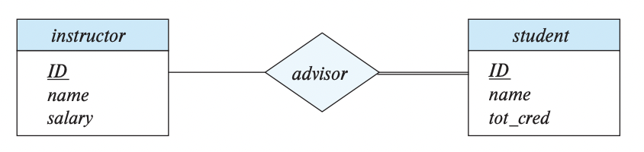

### Weak

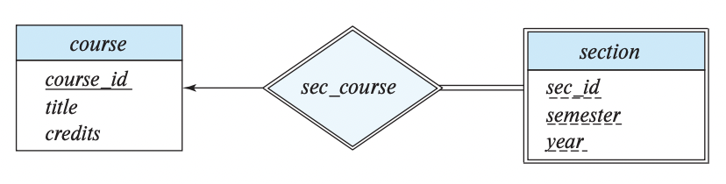

## Sets

## Key attributes

# Relationships

## Degree

### Binary

### Ternary

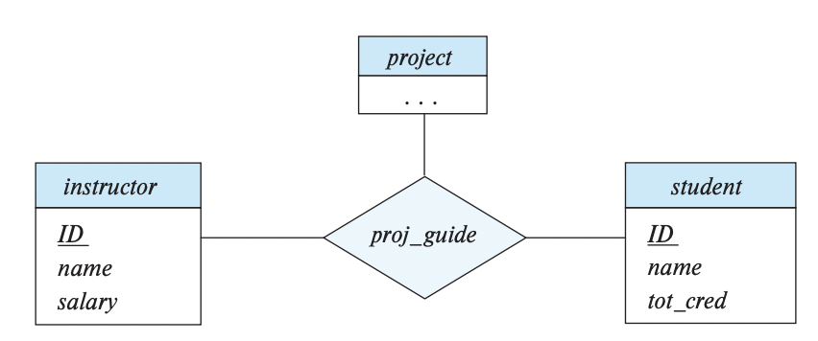

### Higher degree

## Cardinality Ratio

### 1:1

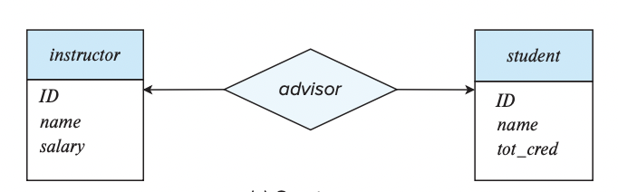

### 1:N

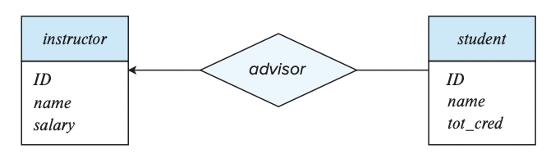

### N:M

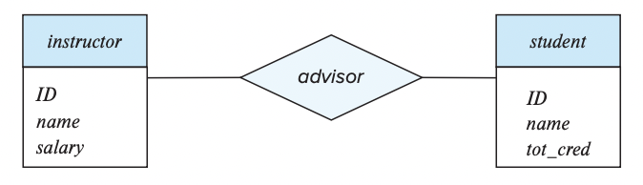

## Participation

### Total



### Partial

# Exercises

## 1

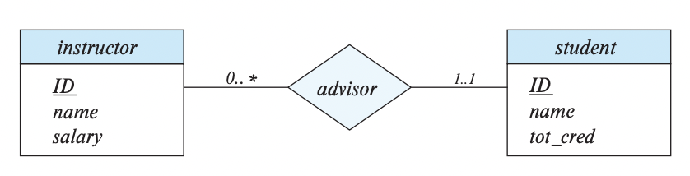

### 2

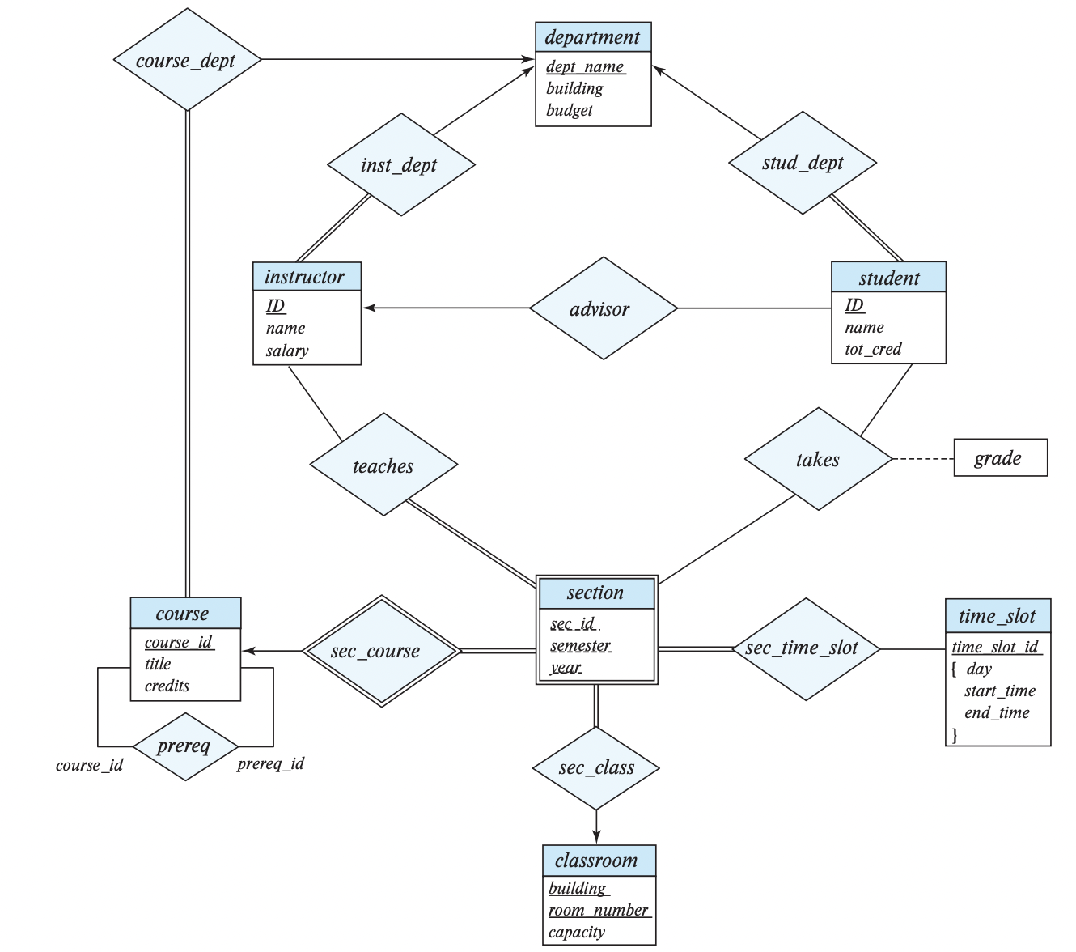

#### schema

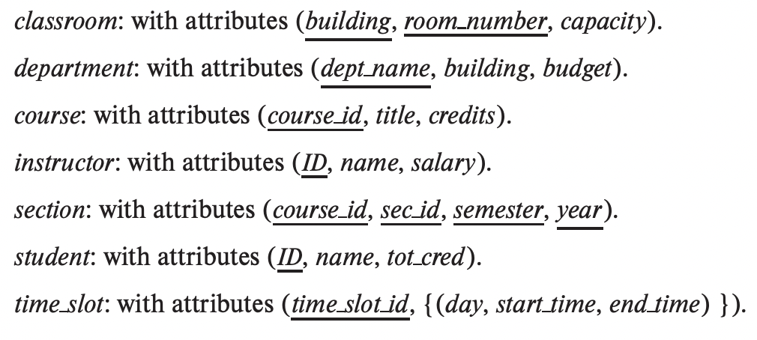

#### schema 2

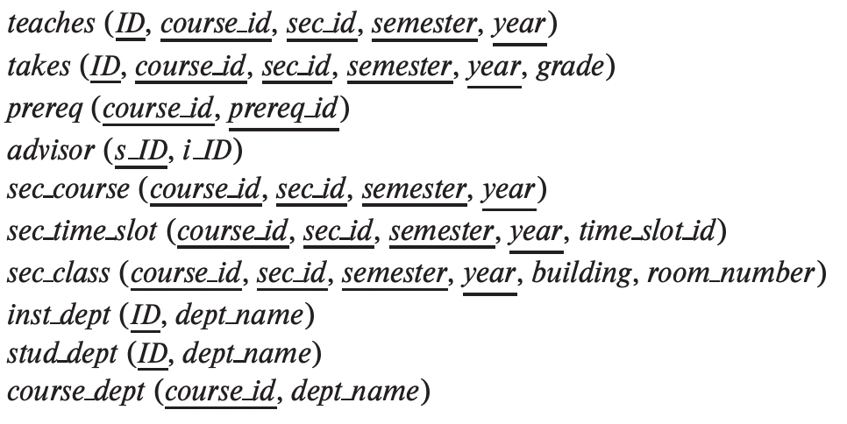

# Convert to relational schema

## simple entity set

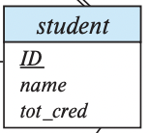

### schema

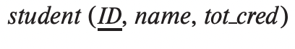

#### Weak entity set

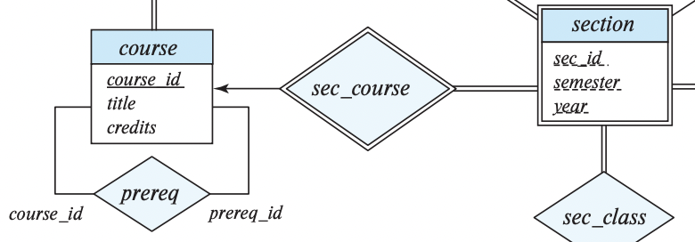

##### schema

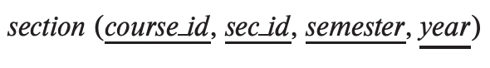

## Multivalued Entity set

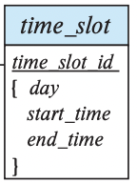

### schema

idea_image_61006642_730x58.png

## Complex entity set

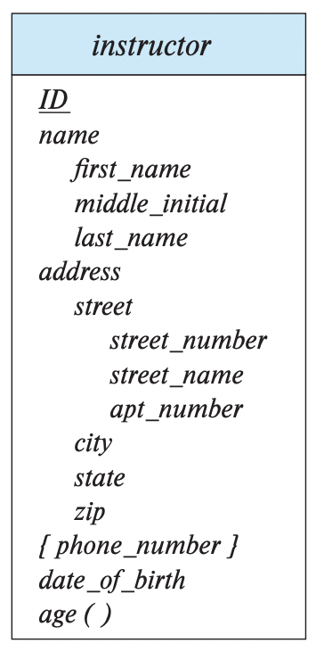

## Relationship set

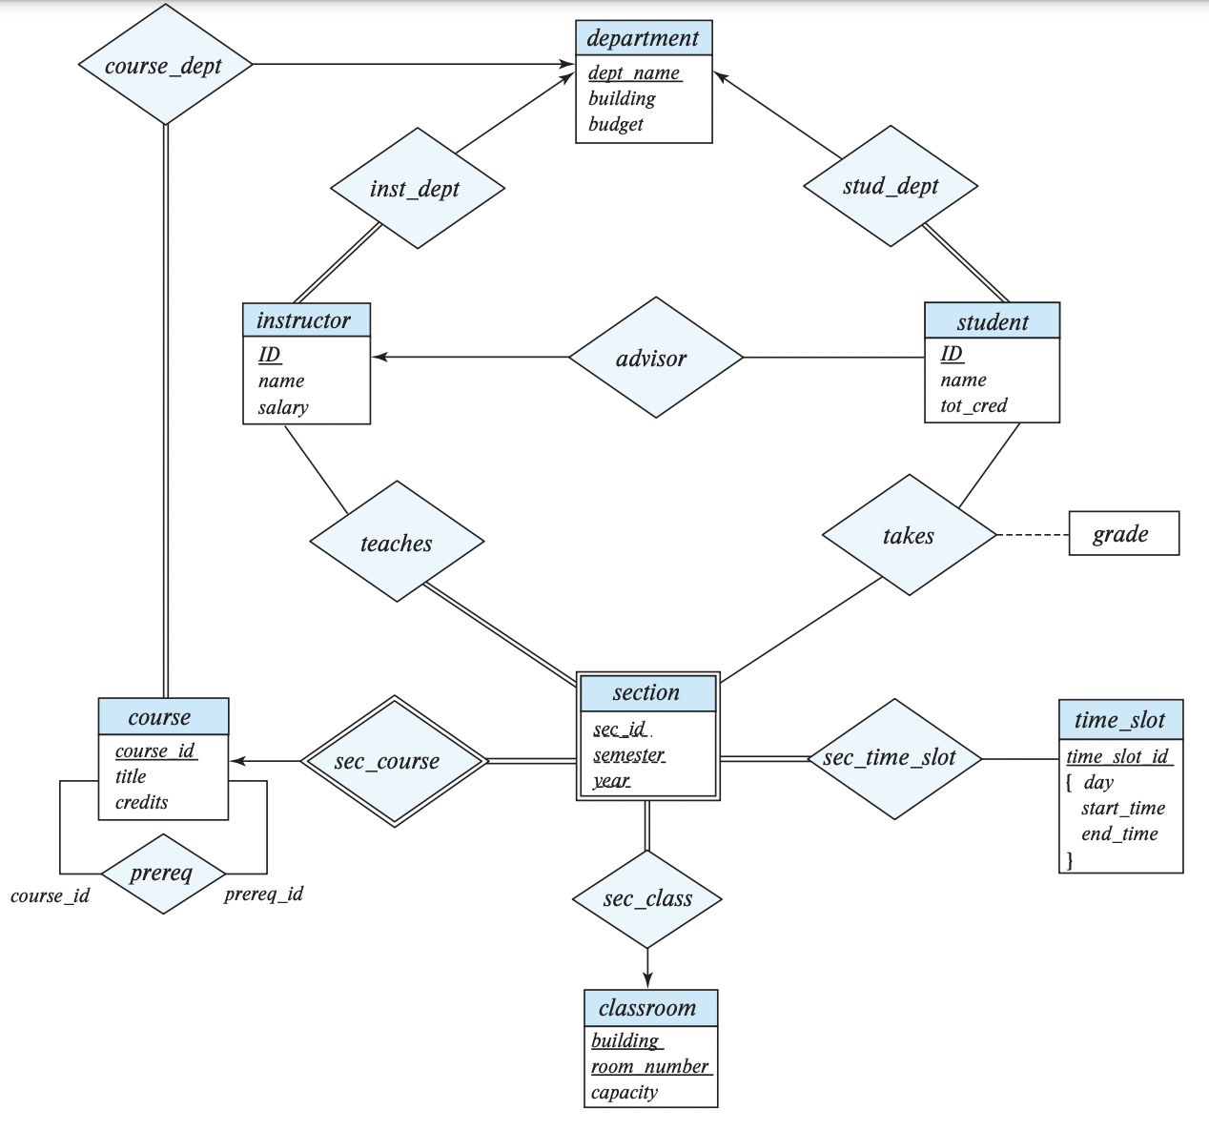

### Schema



## Relationship set

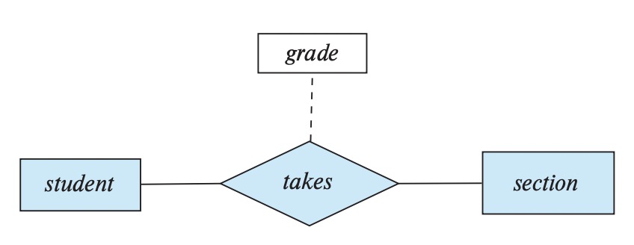

### schema

idea_image_61006756_300x21.png

# 2

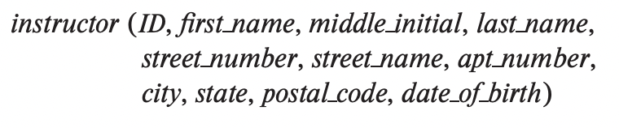

## 3

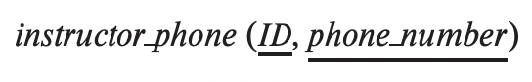

# Minimal schema

## a



### inst dept{ID, name, dept name, salary}.

### stud dept{ID, name, dept name, tot cred}.

### course depts {course id, title, dept name, credits}

### sec class{course id, sec id, semester, year, building, room number}.

### sec time slot{course id, sec id, semester, year, building, room number, time slot id}.

## many-to-one relationship set AB from entity set A to entity set B --------------&------- A in the relationship is total --------------->>Combine A and AB